Name: Tran Khanh Tai
ID: ITITIU21300
Github: KhanhTaiTran/Web-Application-Lab
Lab 8 HW
GET all customers - 200 OK
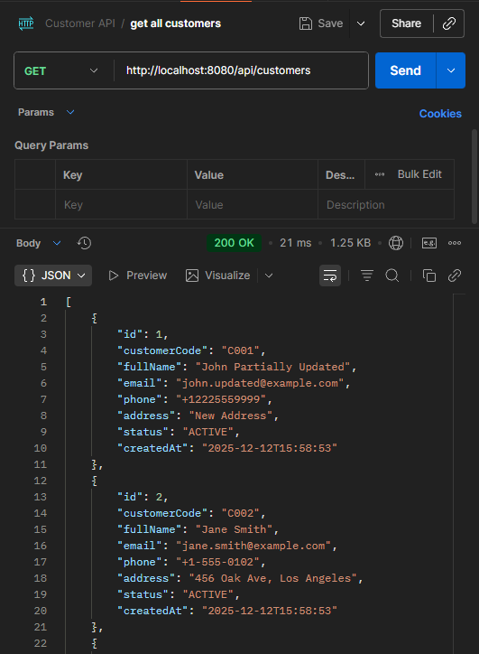
GET by ID - 200 OK
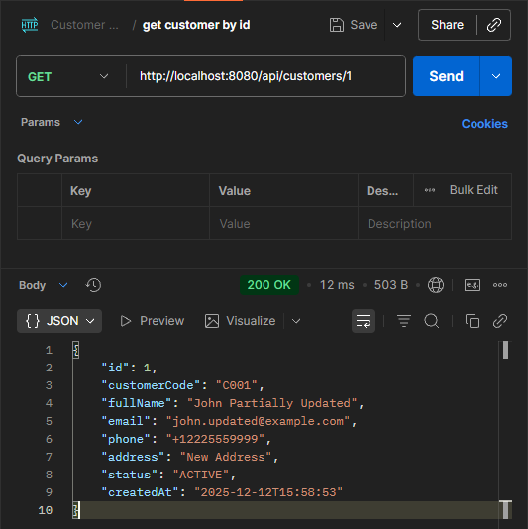
POST create - 201 Created
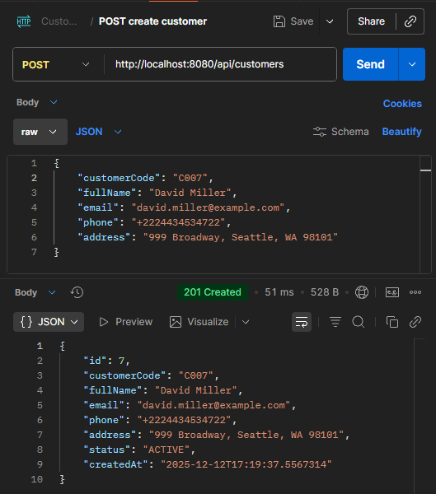
PUT update - 200 OK
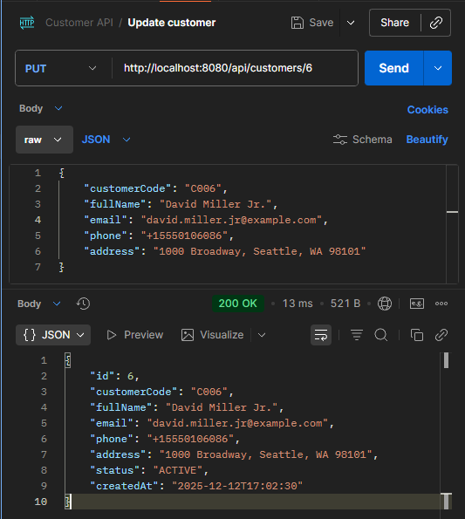
DELETE - 200 OK
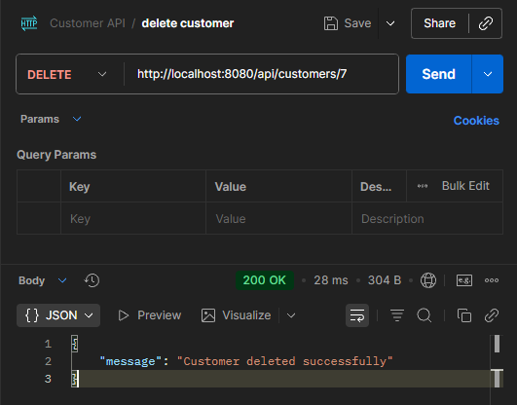
Validation error - 400 Bad Request
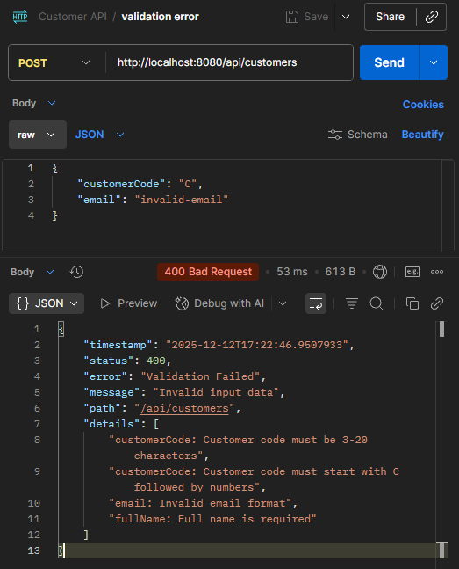

Not found error - 404
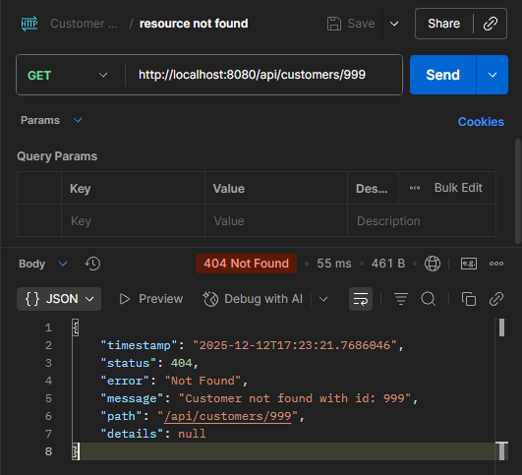
Duplicate error - 409 Conflict
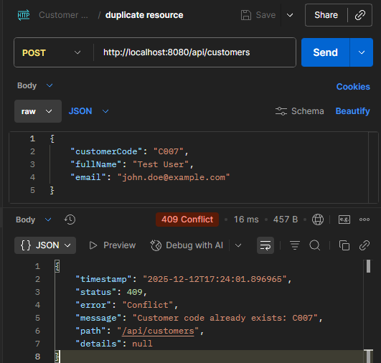
Search results
Advanced search results
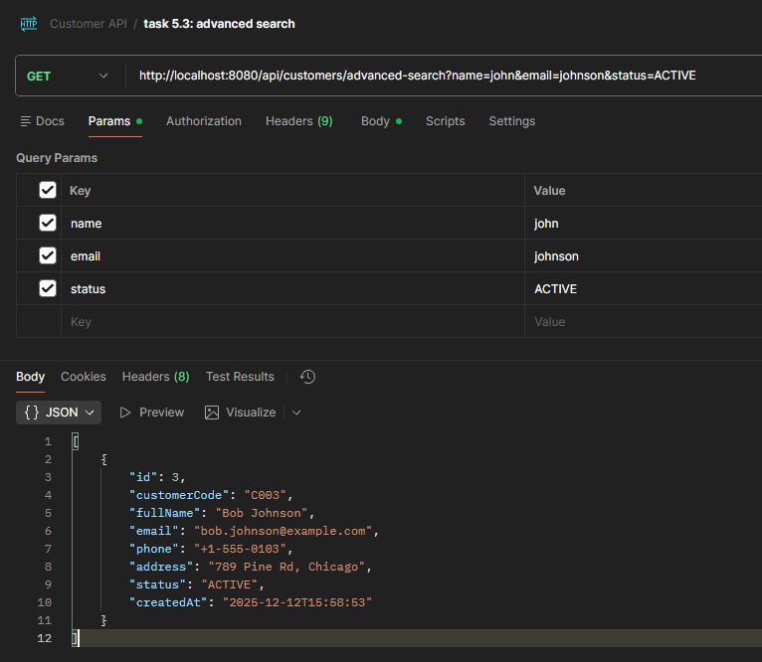

Paginated results
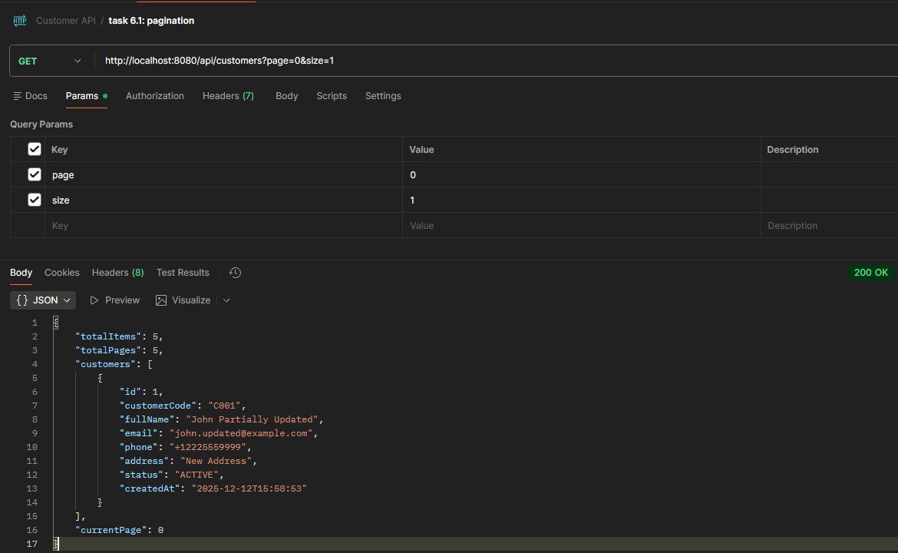
Combination of pagination and sorting results (the first page with customer id is descending)
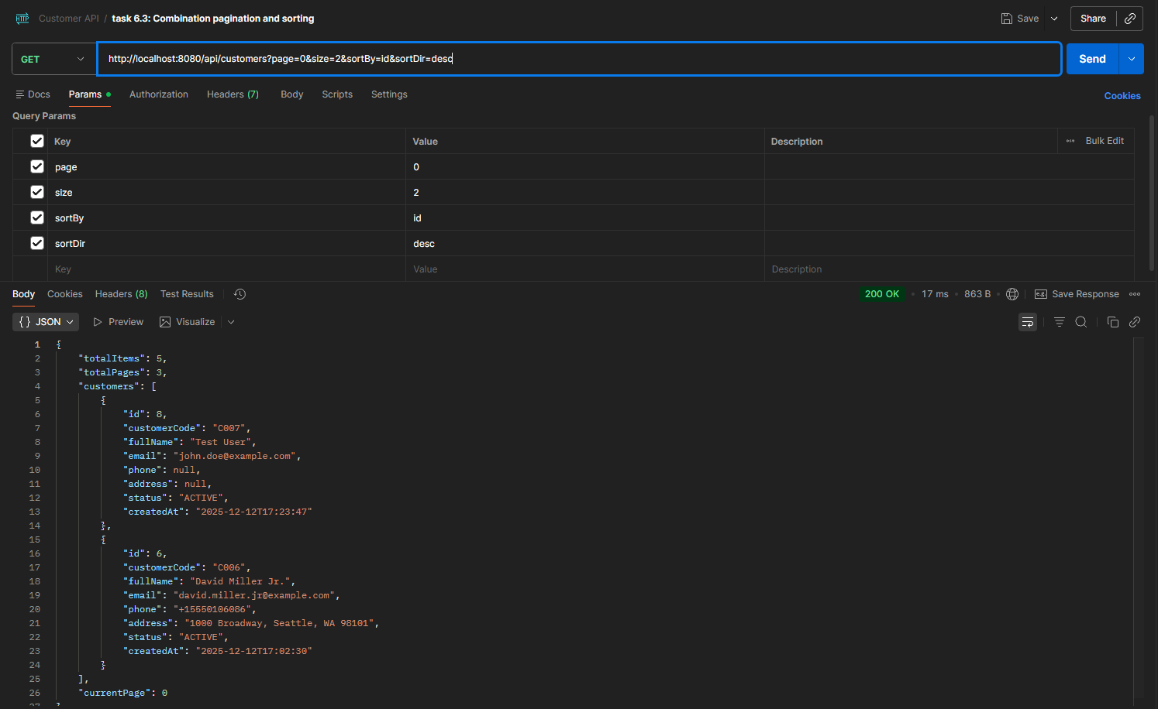

Sorting results(sort by id in descending order)
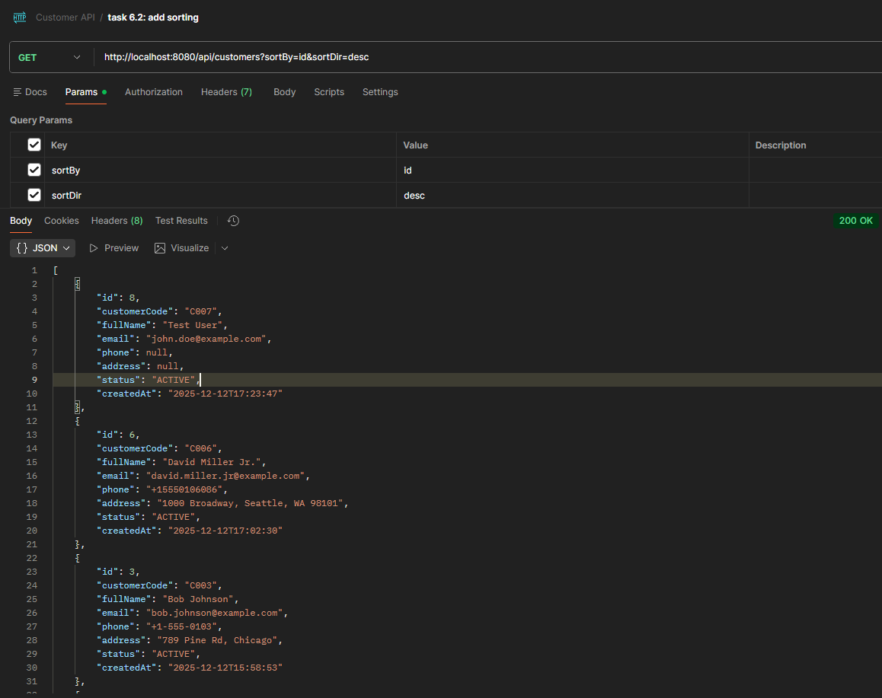

Path: update full name of customer with id = 1
